Documentation: TrashTarget
Trash target is a game that teaches the correct way to recycle common trash items trough a horror / fps style gameloop.

Game design
At the start of the game the player is presented with a start screen explaining the controls and how the game works
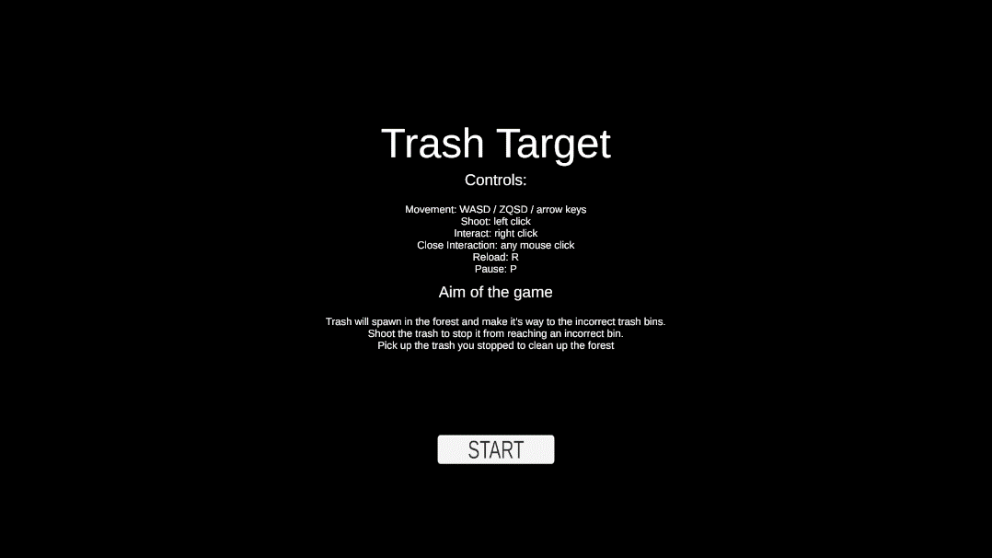
After that the player is immediately dropped into the game. The game world consists of a house with labeled trashcans in front of it amidst a giant scary forest.
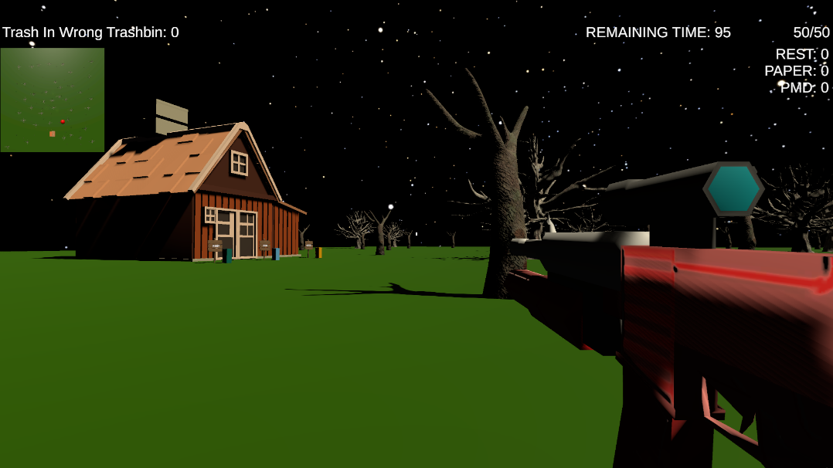
The player can see their current ammo count, the time remaining in the game and the stats on how good they are doing (trash in wrong trash bin and trash picked up). The player also has a minimap (orthogonal camera rendering to rendertexture on canvas). On the minimap they can see their own location trough a red dot (big sphere gameobject that’s part of the player gameobject but only renders on the minimap camera).
When the player goes up to the signs placed behind the trashbins and clicks the interact button a short explanation appears on the screen on what the trash bin should be used for.
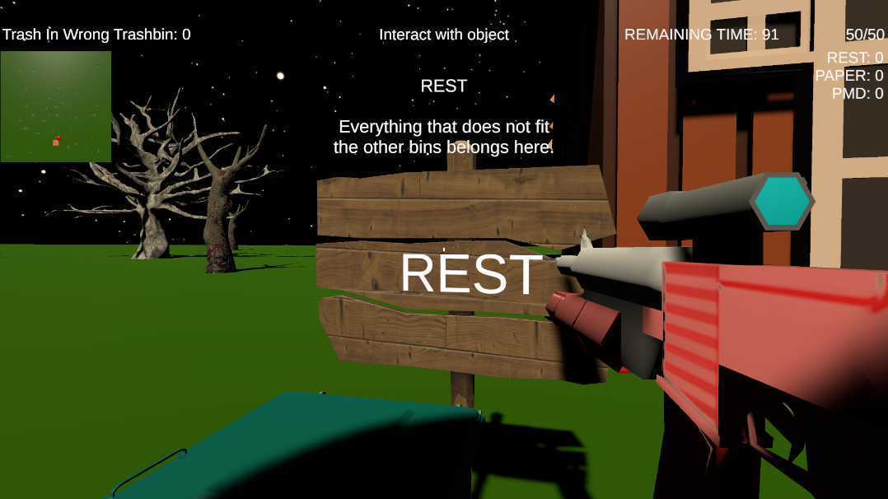
This gets displayed on the normal canvas.
When the user wants to pause the game they can press the ‘P’ key. This pauses the game time and sets the pause canvas as active so it covers the screen to notify the player the game is paused (and tell them the key to unpause).
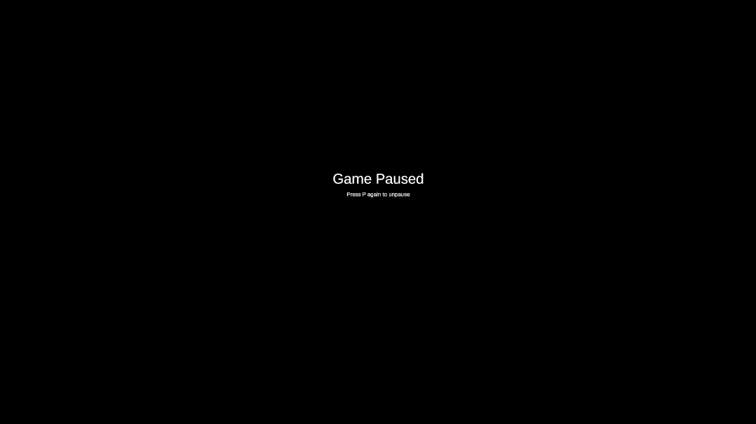
The main gameloop consists of enemies spawning at the backside of the forest (at the top side of the minimap) that will choose a wrong trashcan at random (one where the kind of trash does not belong at all) and will start to move towards that target. It’s the players’ job to prevent this from happening by shooting the approaching trash items. When a trash item is shot (raycast from the gun) it will leave behind a little explosion and a dropped item of itself that can be collected by the player by walking into it (entering the trigger collider). If the player can not stop the trash item in time and it is able to reach a wrong trashcan it will leave behind a different explosion and the wrong trash counter is incremented.
At the end of the game (when the timer runs out) the player is presented with his stats.
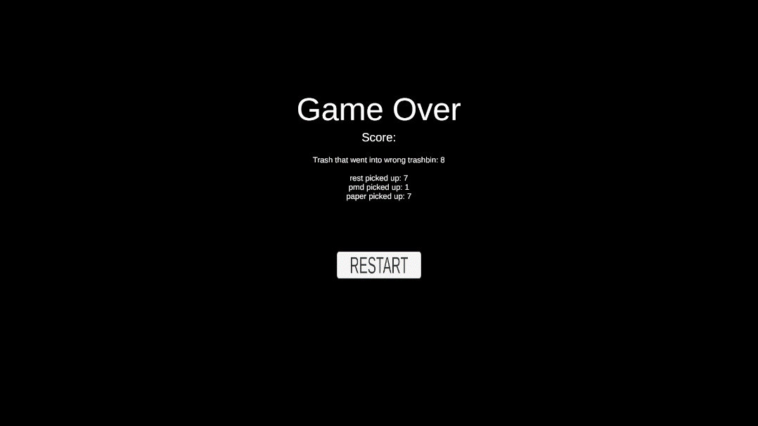
Here the player can choose to restart (to try and beat their previous score) and the game will reset and go to the home screen / start screen again.

Educational value
The educational value in this game is in the explanation of how the different trash cans should be used. Also there is some educational value in the fact that the player gets rewarded (extra points) when they pick up the trash they “kill”.

Contribution to project
Since this was a solo project, there is no contribution report here.

Resources used
- Shot,scifi,powerdown,buildShort,highs.wav by CJDeets
  - https://freesound.org/s/476741/
  - License: Attribution 4.0
- Easy FPS (only MuzzleFlash), Easy FPS, Mario Haberle
  - https://assetstore.unity.com/packages/3d/characters/humanoids/sci-fi/easy-fps-73776

